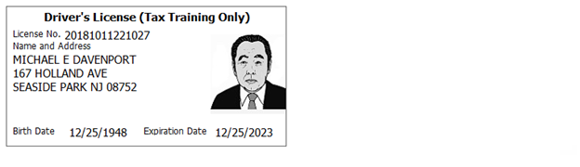
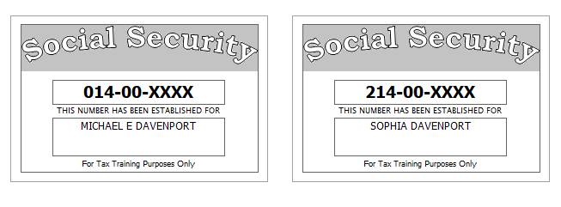

Prior Year Return
- The Davenports did bring their prior year return that was prepared by a paid preparer. From the prior year return you determine
  - They did itemize and take a property tax deduction. After some discussion you determined that they have been itemizing and taking property tax deductions for the past 3 years
  - Line 13 on page 1 of the 1040 is -3,000. Looking into the return you find a copy of a “Capital Loss Carryover Worksheet,” and you see that line 8 (Short-term capital loss carryover) for 2017 is $1,309.
- 2017 1040 Values: Line 8b = 100, Line 16a = 53,300, Line 16b = 47,295, Line 20a = 21,300, Line 20b = 18,105, AGI = 65,400, Line 41 = 48,200, Line 42 = 8,100
Sch A Values: Line 5a State Income Tax = 975, Line 5b Real Estate Tax = 7,000
- Itemized Deductions = 17,200

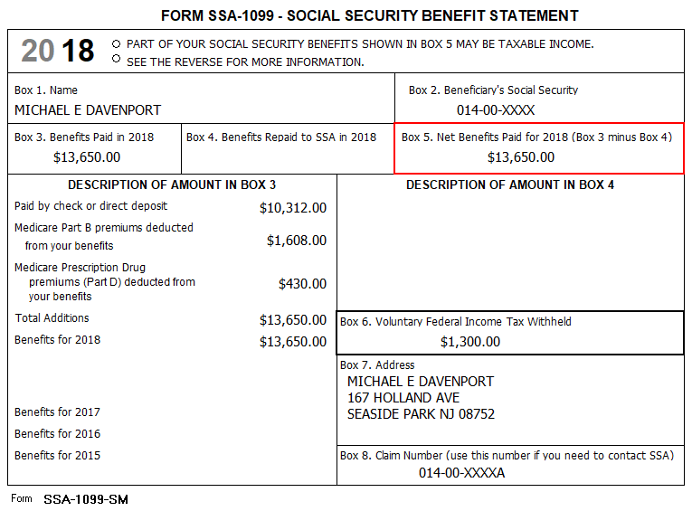
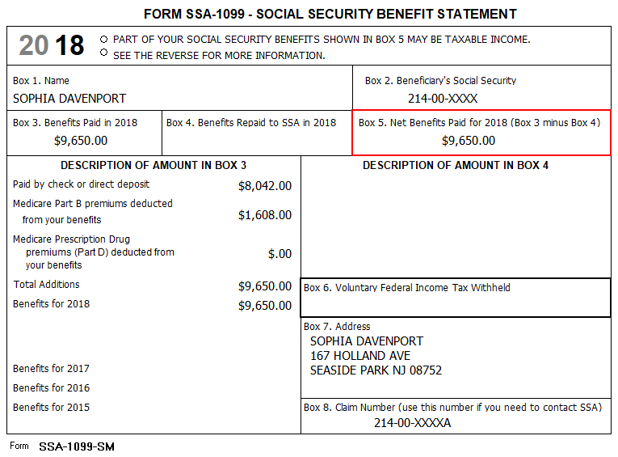

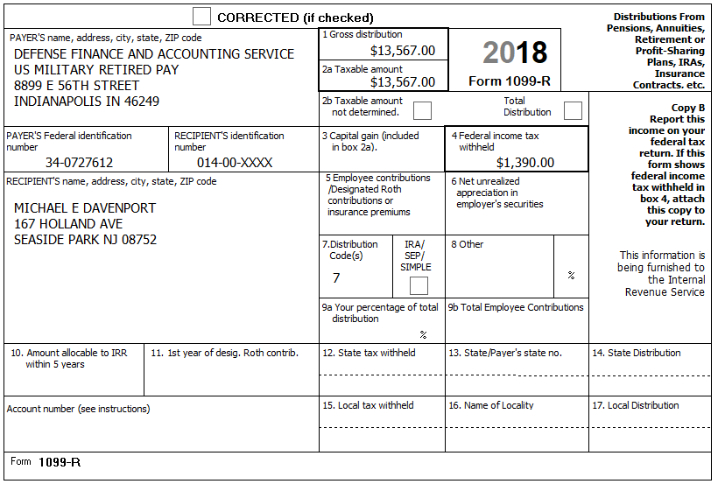

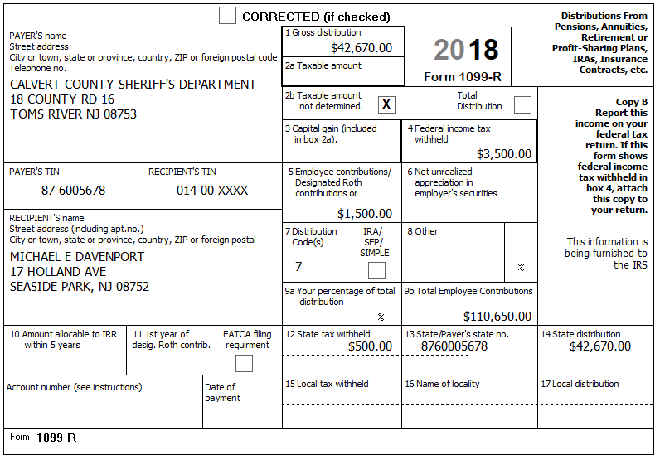
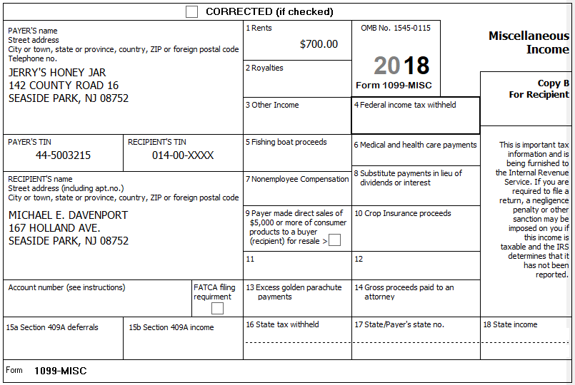
The Davenports have itemized their deductions in the past and though the standard deduction has increased, they believe because of substantial out-of-pocket medical expenses they may be able to itemize. They keep excellent records and provide the following summary:

Medical and dental expenses
Doctors: ....................................... $1,789.00 Ambulance ......................... $960.70
Dental insurance: ........................ $1,616.00 Hospital............................ $3,790.23
Dental crowns: ............................ $2,178.34 Insulin.................................. $980.00
Prescriptions: ............................... $1795.57 Hearing aids ..................... $3,195.90
Medical miles: ............................... 1,843
Taxes paid
Property tax on a parcel of land: $450.00
Use Zip Code 08752 for sales tax
In 2018, they received a Homestead Benefit credit from NJ of $425
In 2018 they received a PTR rebate of $1,150
The Davenport’s PTR base amount is $5,000. Block # 2345, Lot # 7
Michael is a Veteran and did receive the Annual Deduction for Veterans of $250 from his property tax.

Interest Paid
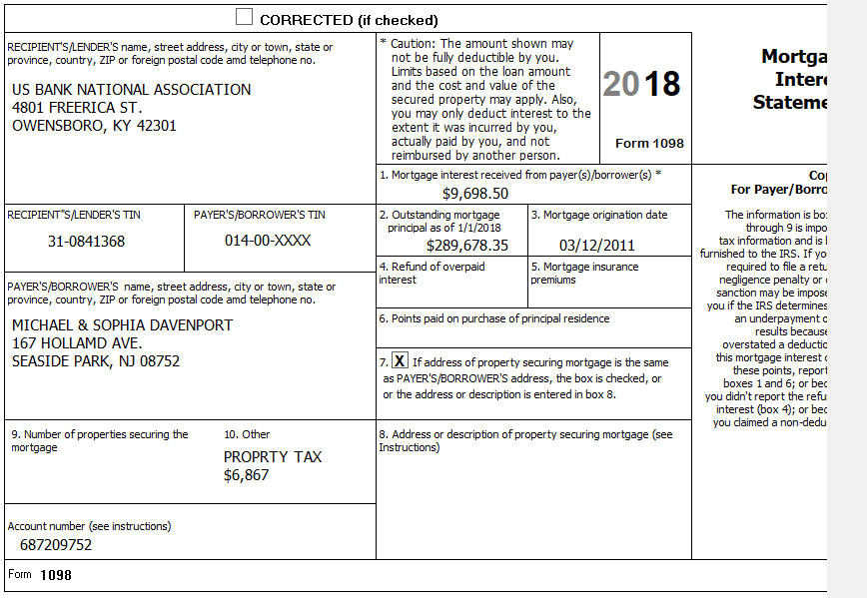
Reminder: Include the property tax/real estate tax when entering the mortgage interest.
Gifts to Charity
St Peter’s Church: ......................... $2,600.00 Chamber of Commerce..................... $75.00
Mayo Clinic: .................................. $1,000.00 Republican National Party ................$50.00
American Red Cross: ....................... $500.00 AARP Foundation............................ $100.00
Goodwill (clothing/household) ....... $418.00
Miscellaneous Deductions
Safe deposit box: ............................ $300.00
Investment fees: .......................... $1,978.00
Tax return preparation: .................. $675.00

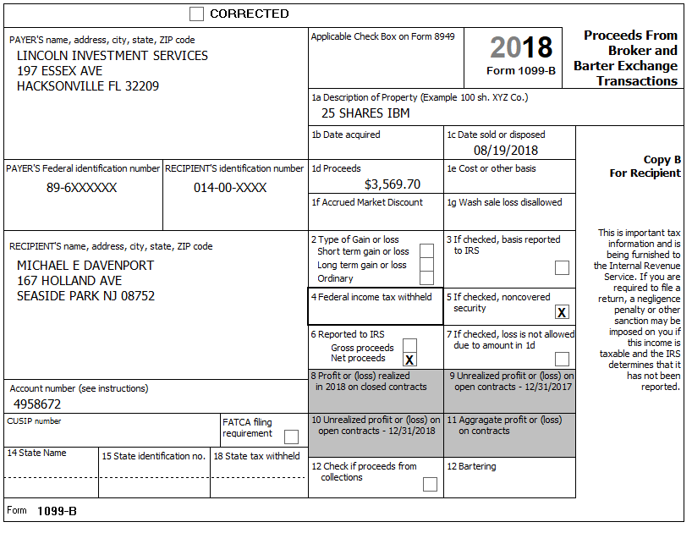

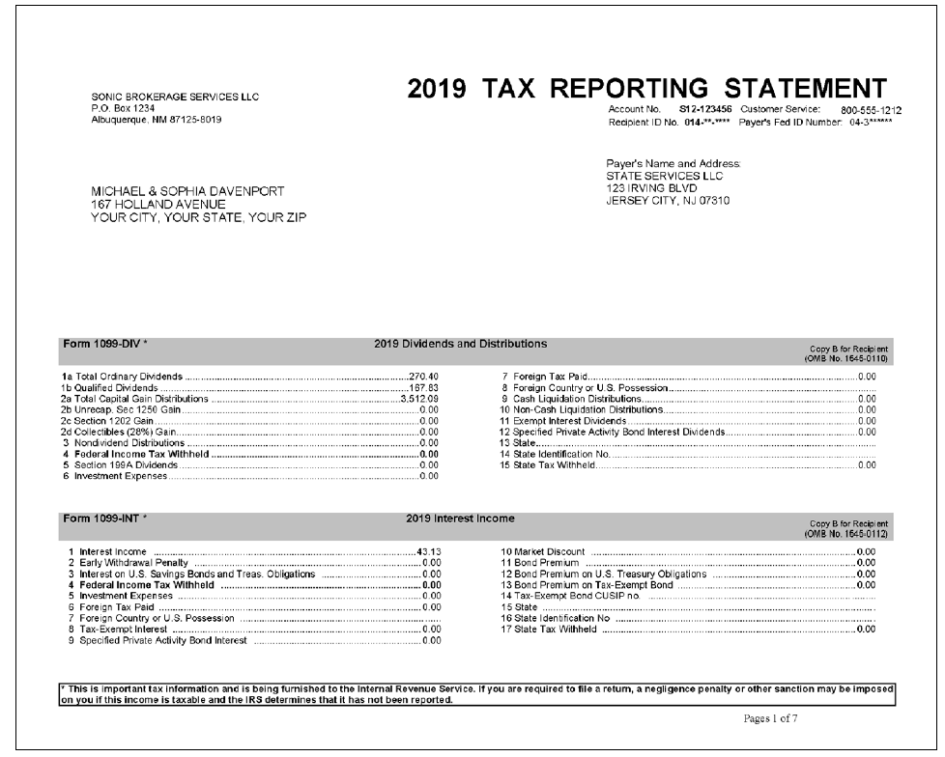

043006789
Box 1a =270.40
Box 1b = 167.83
Boc 2a = 3512.09

43.10

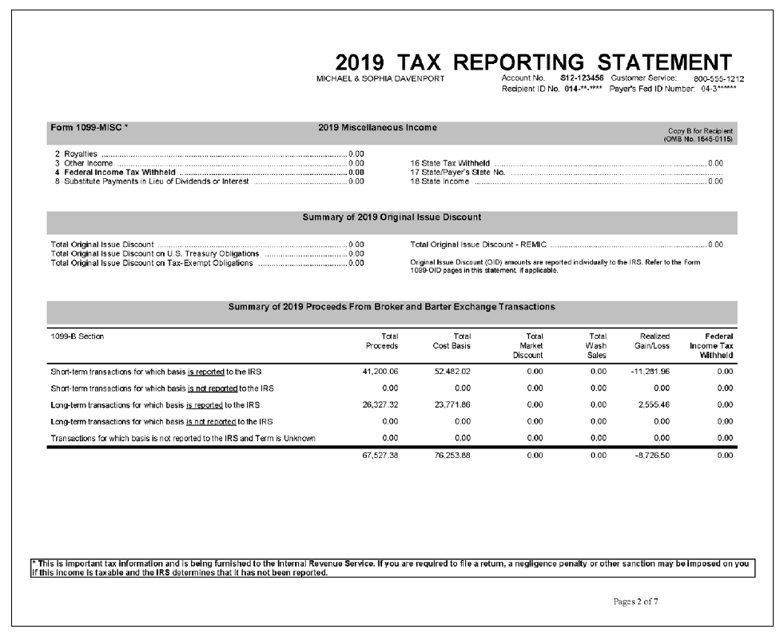

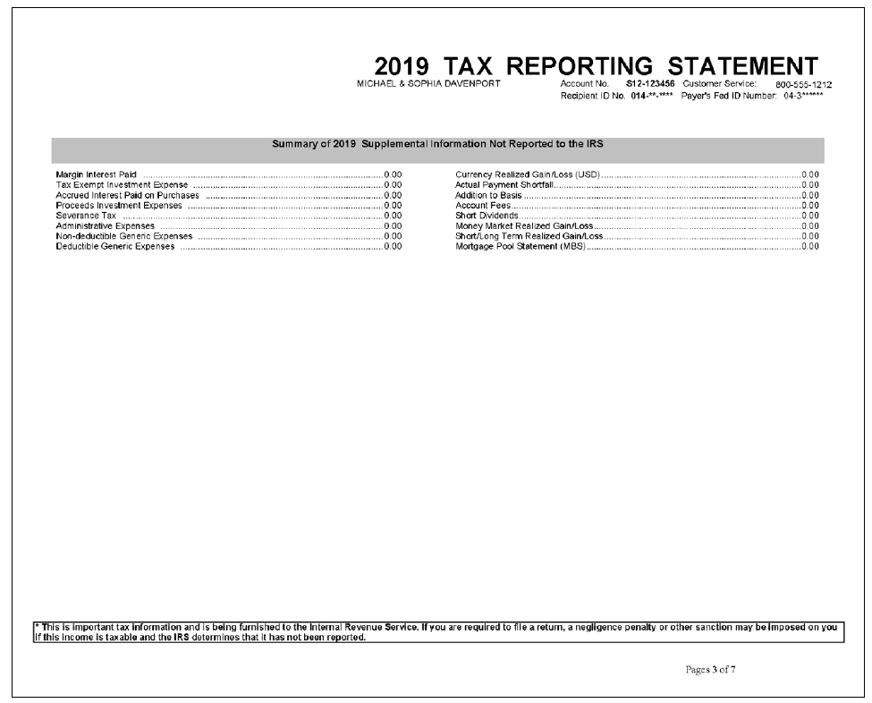

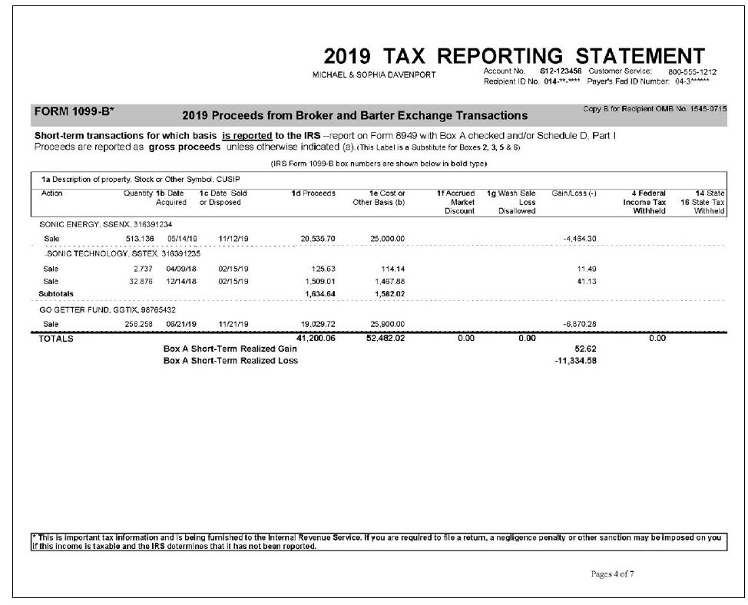
Change all 2019 dates to 2018
Change all 2018 dates to 2017

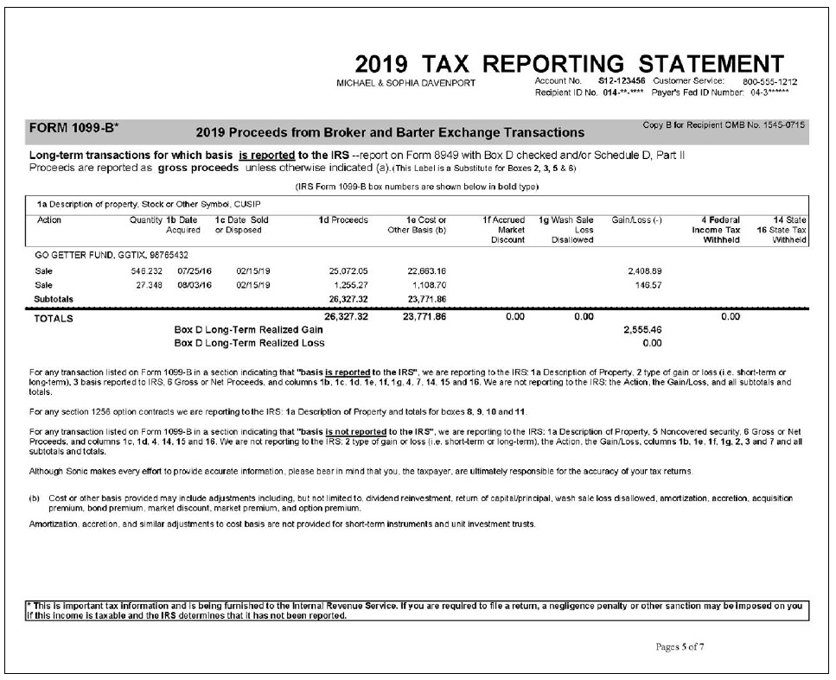
Change all 2019 dates to 2018
Change all 2018 dates to 2017
Change all 2016 dates to 2015

